ADAPTATIONS

GRIZZLY BEAR
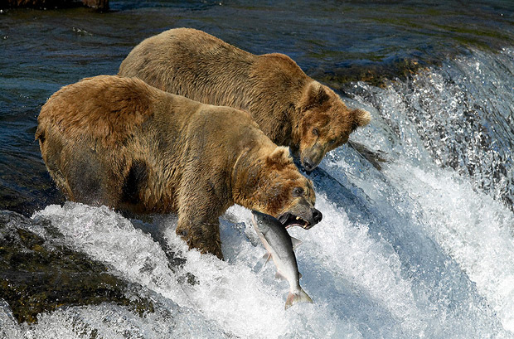
Is a physiological adaptation.
The long hear of bear.
This helps to keep the temperature constant.

THE SEAL
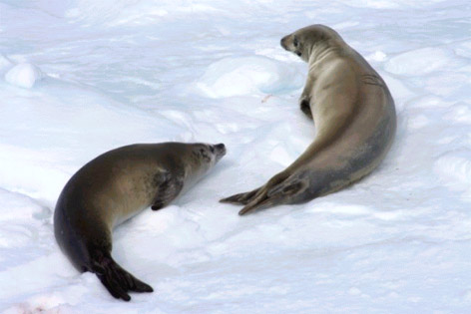
Is a physiological adaptation.
The fat layer.
The fat layer of the seals helps to minimize heat loss.

THE BEE
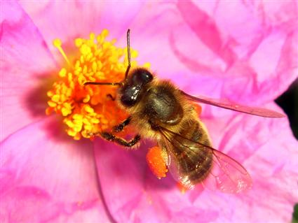
Is a structural adaptation.
The mouth of insect.
The form of mouth of insects would enable it to sucking nectar of flowers.
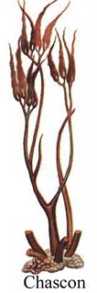
Is a structural adaptation.
This algae developed fixed structures in the bottom of the talus.( fixing up)
The fixed structures can stick to the rocks of the coastal zone to avoid being swept away by waves.
TROPICAL PLANTS
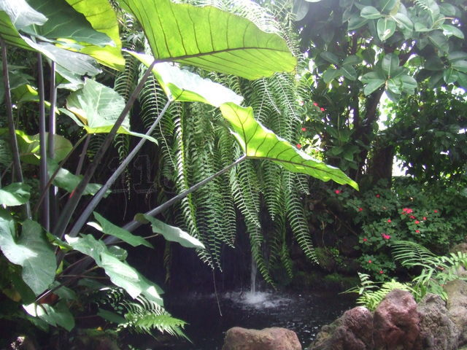
Is a structural adaptation.
The plants with large leaves.
The large leaves to have a maximum surface photosynthesizing.

THE ROSEMARY
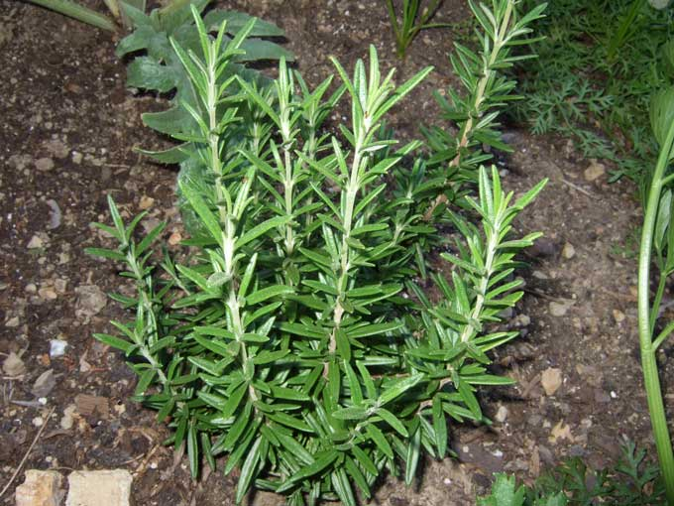
Is a structural adaptation.
It has got a small leaves.
The small leaves help prevent excessive water loss.

