Alexandre Abeijón Pazos 4ºESO
ADAPTATIONS RESEARCH ASSIGNMENT
1. Owl
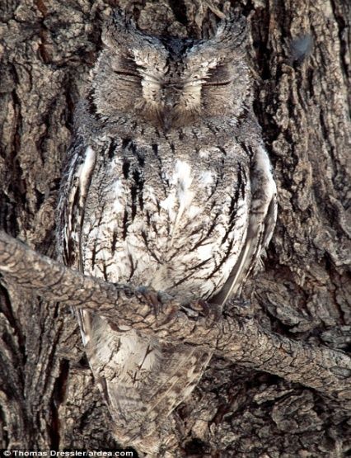
A) Colour
B) Brown feathers
C) The brown feather of the owl camouflages itself in the trees and hides from predators.
2. Frog
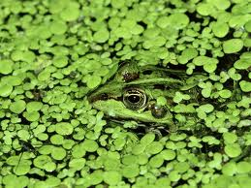
A) Colour
B) Green skin
C) The green skin helps the frog camouflage itself in some plants and hide from predators.
3. Penguin
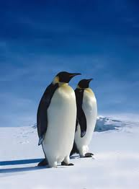
A) Structural
B) Good eyesight underwater
C) A good eyesight underwater may help penguins catch fish for food.
4. Bouganvillea
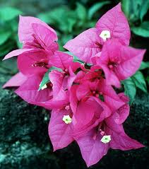
A) Structural
B) Drip tips in the leaves
C) The Bouganvillea lives in the rainforest, so its leaves have drip tips to get rid of the water. Without them, this plant would break down because it cannot support the pressure of the water.
5. Barrel Cactus
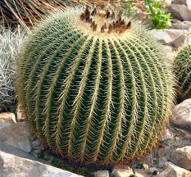
A) Structural
B) Hard and sharp thorns
C) The hard and sharp thorns prevents the cactus from being eaten by predators.
6. Octillo
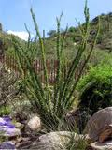
A) Behavior
B) Shed of small leaves
C) It’s adapted to the environment by sheding small leaves and growing new leaves continuously. It also has a shallow root system, which helps to gather rain-water.

